BRIDGE TIMBERS

The timber inserts on bridge 1. are L 2.150mx H 0.3m x W 0. 2m with total of 4.
Rock wall height 0.4m x0.4m width.

To allow water to clear, the timber rail will sit 175mm above the pavement.

The gap between the rock wall and the timber is 100mm on either side and the timber rail will sit just below the wall height at 375mm

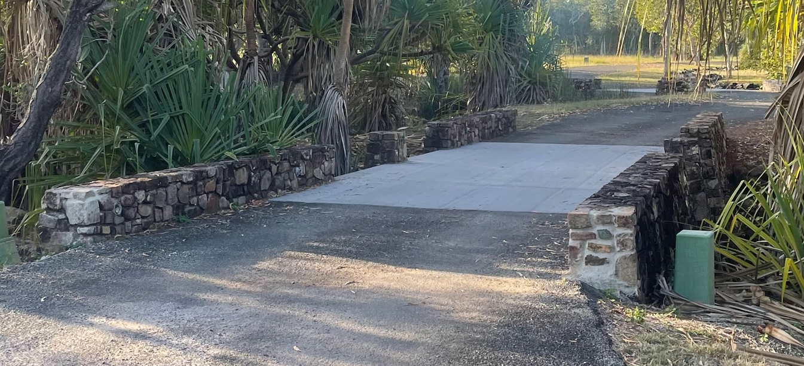
Bridge 1
Bridge 1

The timber inserts on bridge 2 are x L 3.6m x H 0.3m x W 0. 2m with total of 2
Bridge 2
Rock wall height .4m 0.4m x 0.4m width

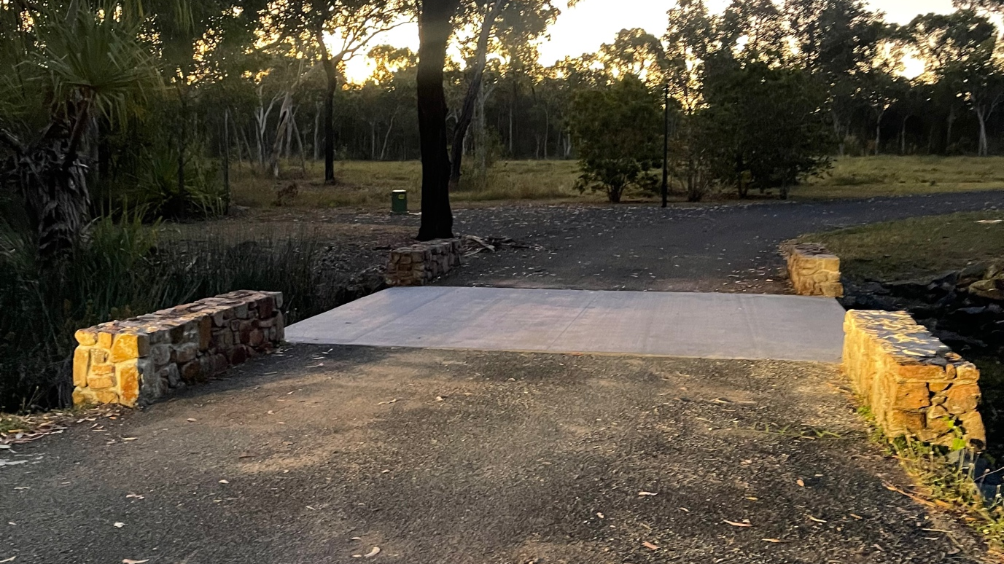
Bridge 2

